# Project Proposal – CS 290

Kendell Crocker

[crockerk@oregonstate.edu](mailto:crockerk@oregonstate.edu)

So the goal is a simple personal website that meets all the requirements listed in the project guidelines. It will be made on my own, using HTML, Javascript and CSS for styling. The page will have a home page (see Figure 1) and three other pages containing various other parts of the requirements. (See figure 2) The other pages will contain things like: A submittable form, a more dedicated about me tab, and also external links to things like github, facebook, or tutorials used while making the site. (Gotta cite them somehow!) The first step will be doing some basic setup, like getting all the pages made. Once the pages are on the server, I can really work on writing them and formatting them. Finally, after the basic requirements are done, I’d like to continue adding features until the due date of the project. That last step will depend on how much time I have left, but I do have some ideas.

**Figure 1: Home Page**

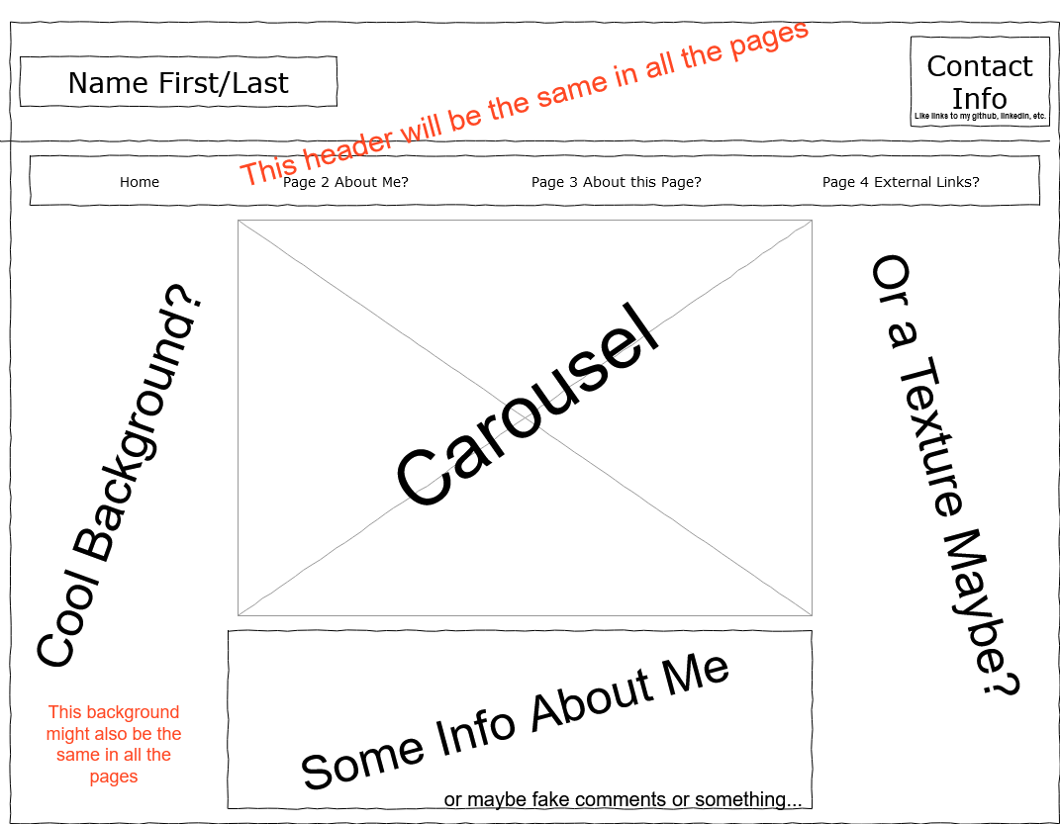

**Figure 2: Generic Other Pages (To Be filled in later depending on needs/ideas)**

